Video Game SRS Document: (PLACEHOLDER NAME)

Jaafar Kaoussarani

William Xie

Marianick Benoit

1. Introduction

Video game programmed using the LOVE2D API with the Lua coding language. Event-based programming. The game itself will be

1. Opening the game and menu

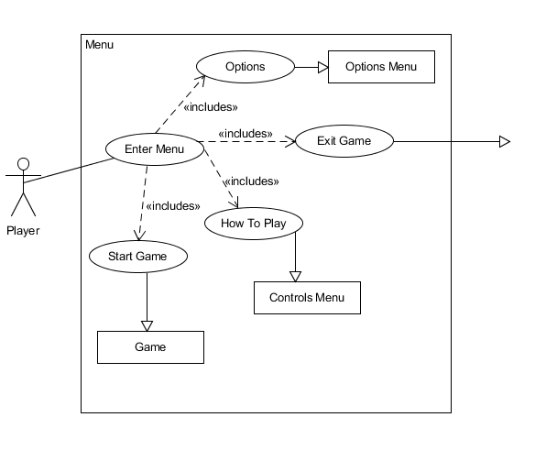As soon as the game opens, the team name will display, followed by a menu. This menu MUST contain a Start button and an Exit button. How to Play and Options menu preferable but can be omitted if time is lacking. Once an optional button is pressed, it will display a new menu, either replacing the previous menu or displaying it on top of the previous menu.

Main menu use case

2.1) Options Menu

Current options menu would be very simple. Simple volume controls for now. Resolution options and others may be included if time permits.

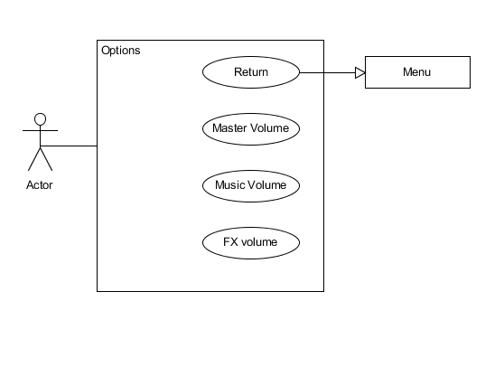

2.2) How to Play Menu

Simply displays basic controls. Will not changeable.

1. Game